**TEST BED SET UP**

1. **Given Step up**:

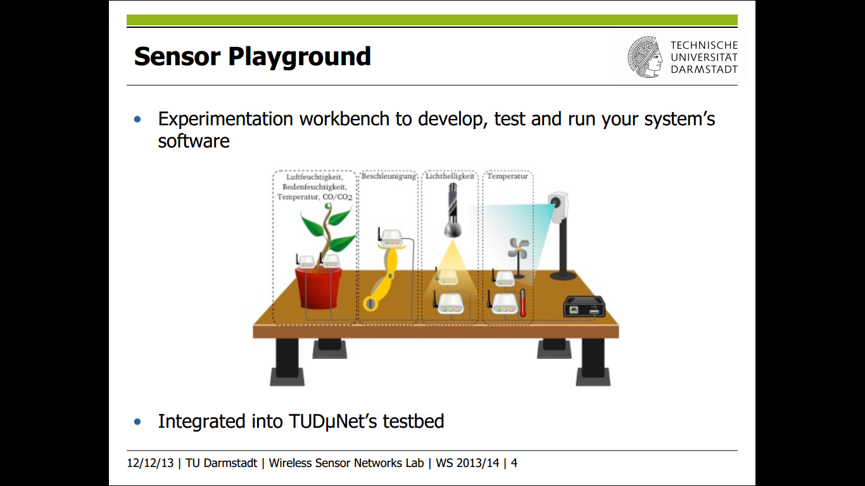

1. **Proposed Step up:**

Right Plant : Peperomia

Left Plant: Kalanchoe

USB LIGHT R

USB LIGHT L

sink

USB FAN R

USB Heater R

USB FAN L

USB Heater L

**STEP 1:**

1. On board Sensor (light, humidity and temperature), Co2 and Moisture sensor (both left and right) will collect a values and do sampling.
2. If value is below /Ok/ high than threshold value then send command to sink.

L = Left plant

R= Right plant

USB LIGHT L

Right Plant: Peperomia

Left Plant: Kalanchoe

USB Heater R

USB Heater L

sink

USB LIGHT R

USB FAN R

USB FAN L

**STEP 2:**

1. When commands will be received by sink , it will send ON/OFF action to corresponding actuators :

FAN: CO2 (HIGH / OK)

LIGHT: LIGHT (LOW / OK)

HEATER: MOISTURE (HIGH / OK)

1. States are stored in the sink.
2. No action will be sent by sink until new command is received.

**4.3 Current Step up:**

1. [3009] On board Sensor (light, humidity and temperature), [3002] Co2 and [3007 and 3003] Moisture sensor (both left and right) will collect a values and do sampling.
2. If value is below /Ok/ high than threshold value then send command to sink 3001 and 3008.
3. When commands will be received by sink 3001 and 3008, it will send ON/OFF action to corresponding actuators :

FAN: CO2 (HIGH / OK)

LIGHT: LIGHT (LOW / OK)

HEATER: MOISTURE (HIGH / OK)

1. States are stored in the sink 3001 and 3009for respective plants.
2. No action will be sent by sink until new command is received.

3001 (sink2)

3008 (sink1)

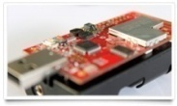

Light2

Light1

Fan1

Fan2

3003

moisture sensors

Heater2

3007

3009 (on board sensor

3002(C02sensor)

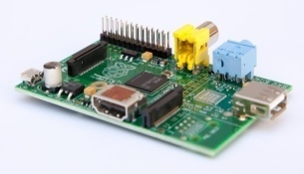





Heater1

Commnad from 3002 to 3001 & 3008

Action ON/OFF to Light

Commnad from 3009 to 3001 & 3008

Action ON/OFF to Heater

Commnad from 3007 to 3001 & 3003 to 3008

Action ON/OFF to Fan

|  |  |  |  |
| --- | --- | --- | --- |
| ****Serial No.**** | Node Type | Node ID | Position |
| **FTWU3V1Q** | Sink Node | ID 3001 | RIGHT |
| **FTWGX4RJ** | CO2 Sensor | ID 3002 | RIGHT |
| **FTWU3VN7** | Soil Moisture Sensor | ID 3003 | RIGHT |
| **FTWG8BJM** | Soil Moisture Sensor | ID 3007 | LEFT |
| **FTWGX4YY** | Sink Node | ID 3008 | LEFT |
| **FTWGX5V2** | Onboard sensors | ID 3009 | LEFT |

